DOCKER TASK

Submitted By:
KASHAN ZULFIQAR

Dated : 02/04/2026

Task a:-
Clone ant three tier application from github and containerize it uisng Docker Compose
Goals:
1.Working app on browser.
2.DB data persists after restart.

Solution:-
Step 1: Clone the Project
Start by downloading the source code from the repository to local server.
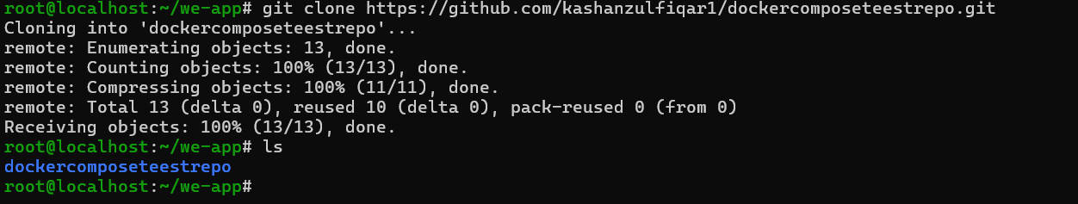

Step 2: Create the Dockerfiles
Since the frontend and backend run in different environments, you need two Dockerfiles.
Docker file for server
Dockerfile File explanation
- Using base image node because we have to use npm commands.
- Then setting working directory to app
- Installing dependencies
- now copying data from outside the container to app folder and expose port 5000
- Now at the end setting default execution behaviour so node backend server starts when container is in running state
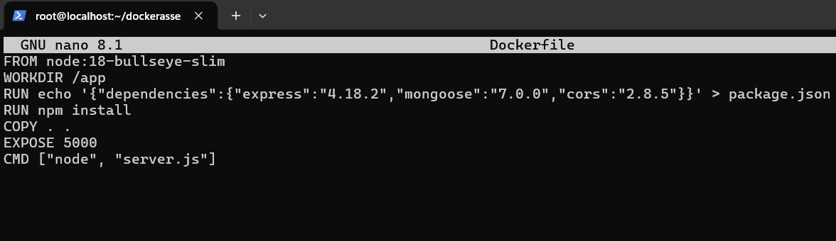
Docker file for client
Dockerfile File explanation
- Client is just a index.html file that is running on nginx.so we are coping index.html to the default location of the nginx html file location.
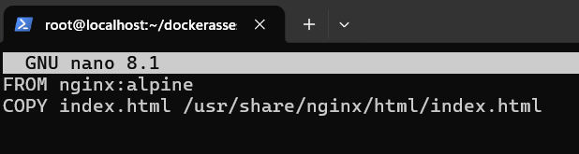
Step 3: Create the Docker Compose File
- Create a docker-compose.yml in the root directory to connect and run all three services (Frontend, Backend, and Database).
- Our second goal is achieved here we will attach volume to mongo db so even if our containers are removed the data is not deleted so we have made a volume mongo_data and attached it with mongodb container.
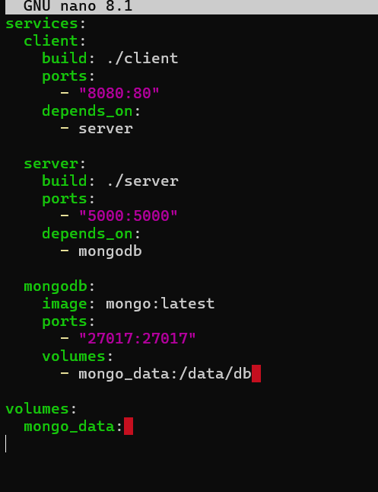

Step 5: Build and Launch
- Use the compose command to build custom images and start the network.
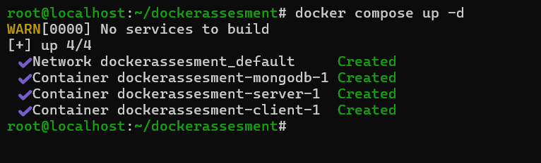

Step 6: Verify website working
- Access the app on the port 8080 on which front end is serving and checking if the app is working or not.
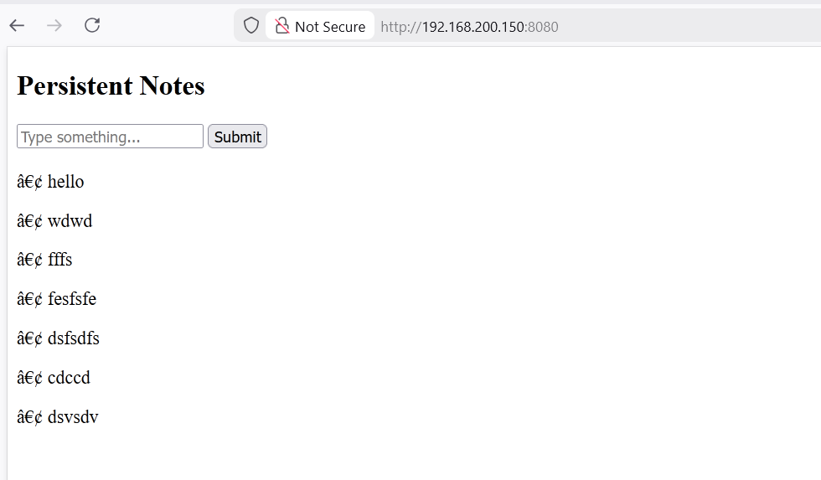
Step 7: Verify Persistence
- To verify Persistence we destroy all containers and again using docker compose up command start the container and check if the data that was entered before is available or not.
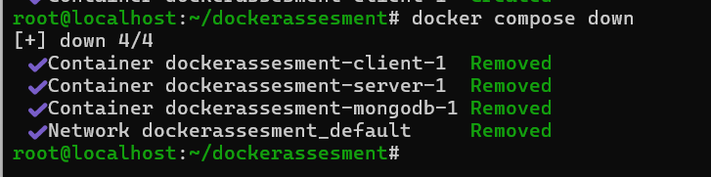
Starting containers again
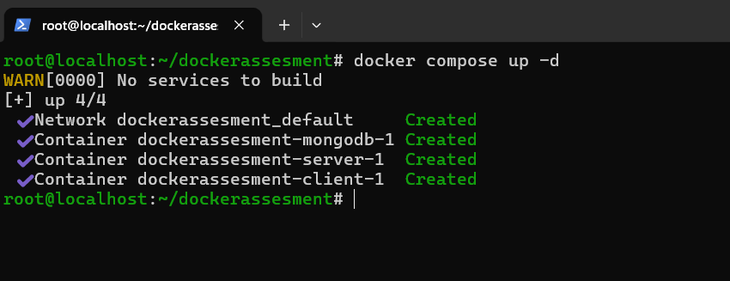
Checking
- The data is available after the containers weere deleted and then started again so task is completed.
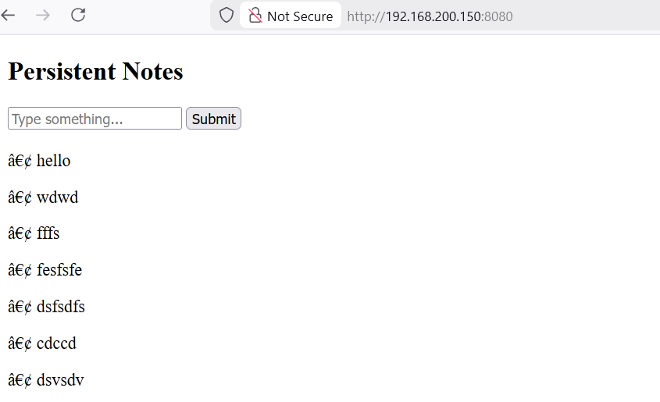

Task b:-
Design and implement a Docker-based solution in which two different services run on the same port.
Solution:-
two services cannot bind to the same host port simultaneously, the standard solution is to use a Reverse Proxy.
Step 1: The Routing Logic
- Create nginx.conf in the task2 folder. This file tells the Proxy container to send /service1/ requests to the nginx1 container.
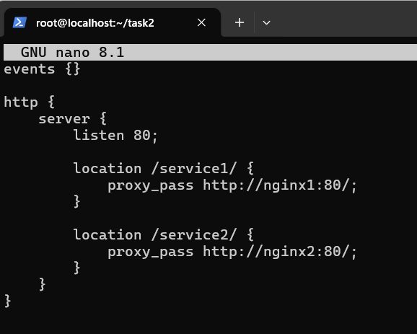
Step 2: Docker compose file
- Create docker-compose.yml. Notice that only the proxy service has a ports mapping. The other two are "hidden" from the host.
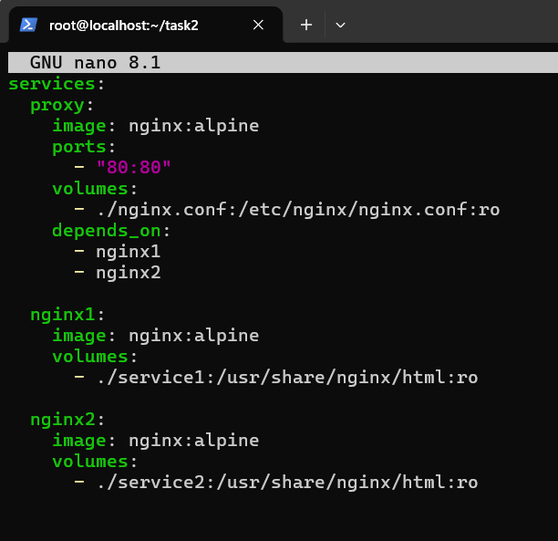
Step 3: Deployment Phase
- Launch the services using docker-compose up -d
- Verify status: docker ps
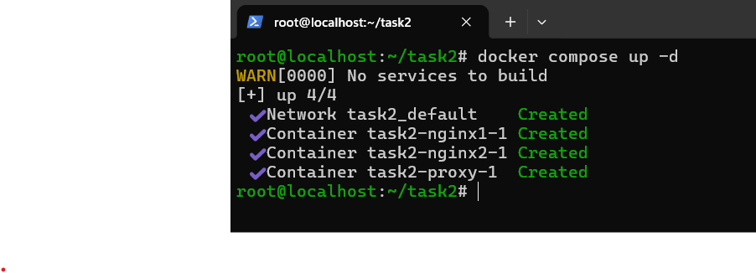
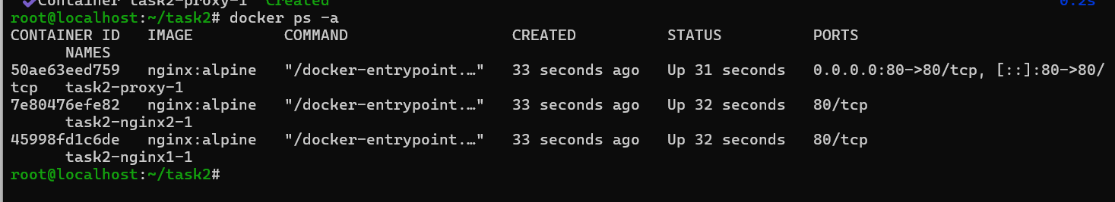
Step 4: Verification
- Since the nginx1 and nginx2 hostnames only exist inside the Docker network, you must test through the Proxy at localhost.
- As we can see both services are accessable on port 80.
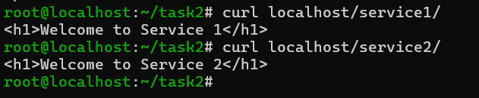

Task c:-
Set up multiple docker containers that log thair output toa centralized location which can be monitored from a single place.
Solution:-
Step 1: Prepare the Environment
Make dockercompose file
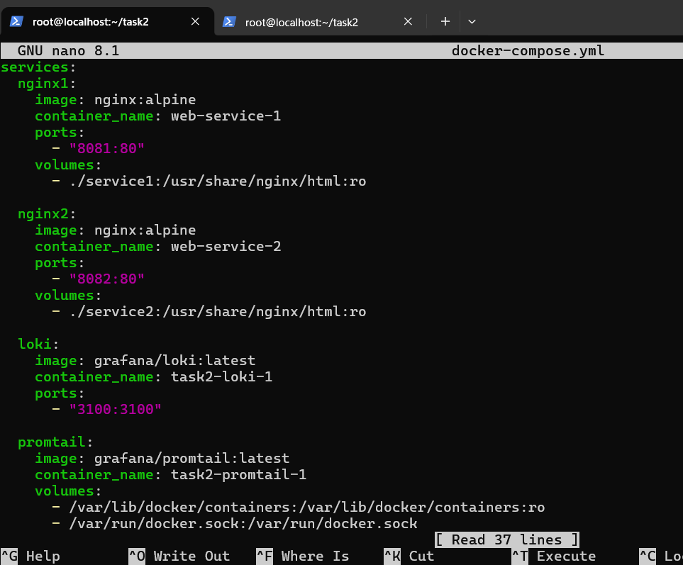
Step 2: Create the Log Collector Config
Promtail needs to know where the Docker log files are located on your host to "scrape" them and send them to Loki.
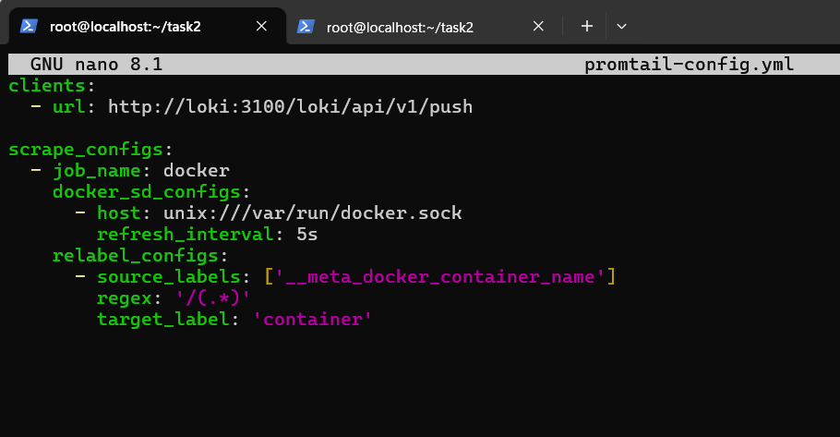
Step 3: Run and monitor
Launch everything: docker-compose up -d
Generate Logs: Visit your Nginx containers or curl them internally to create some access logs: docker exec nginx-service-a curl localhost
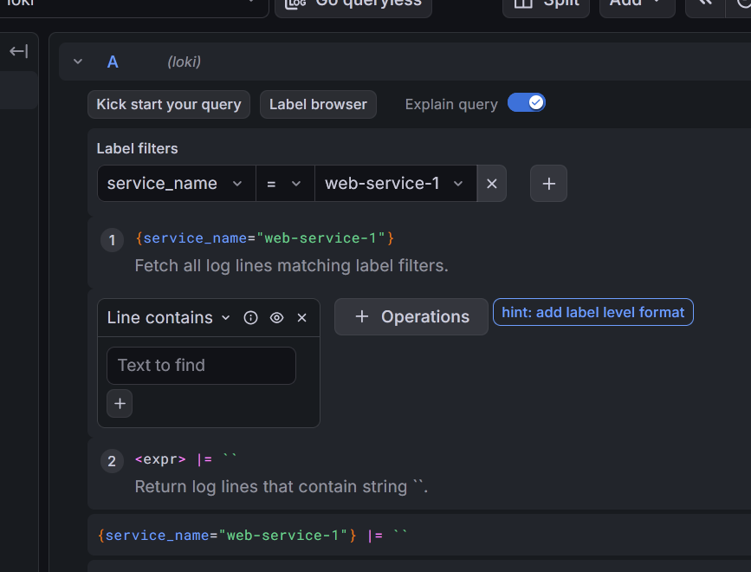
Below screen shot shows live logs.
